ZOOM F.A.Q
FREQUENTLY Asked questions
Can I have an account?
Any South Seattle College employee may request an account. To do so, visit http://www.southseattle.info, click employees and submit a help request via the support form. At other campuses, please contact your Zoom Administrator.

Can students get an account?
Students only need a link or meeting invite to participate in a session and don’t require an individual account. Zoom does offer free accounts with limited features to the public.

Do participants need an account to login?
Only the meeting initiator or host needs a Zoom account. They can then invite participants who will only need a link to join the meeting/session.

Does Zoom work with Canvas?
Participants only need a link to access a Zoom session and links can easily be integrated into Canvas.

What if I don’t have a microphone or camera?
Zoom can be used without a camera or microphone. Participants can use chat or the call in option to communicate in the meeting.

What is Zoom?
Zoom is a videoconferencing solution for desktop, web and mobile that works on multiple platforms including Windows, Mac, Chrome OS, iOS and Android devices. Zoom features interactive video, audio, screen sharing, chat and recording features. Zoom can be used for teaching, learning and administrative use.

Use Zoom to:
- Virtually engage with students  - Conduct virtual meetings  - Record lectures, class sessions or meetings  - Schedule sessions via calendar invites  - Launch sessions on the fly | - Share your desktop, websites or documents  - Share and draw on a virtual white board  - Send files to groups or individuals  - Stream presentations of events  - Host online office hours

Requesting a Zoom Account
South Seattle College employees may request a Zoom account by visiting http://www.southseattle.info, clicking on the employee’s link and submitting a help request via the support form. Once you have requested an account you will receive an email (in 1-2 business days) with instructions on activating your account. At other colleges please contact your Zoom administrator.
Different browsers and devices may have a different processes for downloading Zoom. If you have difficulty with one browser, switch to another.

Setting Up Zoom
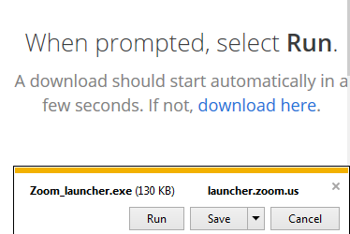
The Zoom client is available for a variety of operating systems, browsers and devices. Every time you start or join a Zoom meeting you will be prompted to download the appropriate client. Once installed, the Zoom client will open to the correct meeting.
Zoom also has a web client (via the browser) with limited features. The web client option will appear once you have tried (and failed) to download Zoom. As a host, you can control the appearance of this option in settings.

Audio and Video
Choose your audio option
All Zoom users select their audio prefrence.
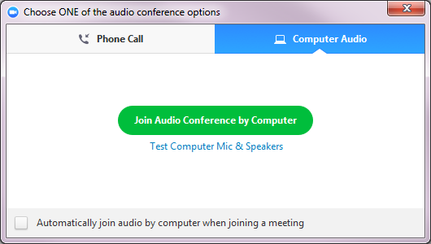

Test Computer Mic & Speakers First
Establish that your equipment is working by selecting the test option first.
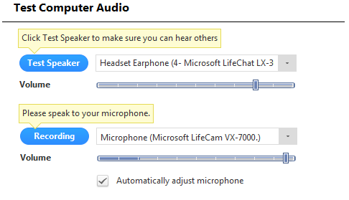

Phone Call Option
You will need the phone# and meeting ID to call in. The number is not toll free and you may not be able to call with a campus phone.
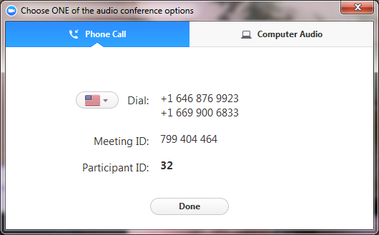

Zoom offers an audio and video experience. Anyone in a meeting can specify their audio preferences, Phone Call for a phone in option or using Computer Audio to join from your computer.
- Computer Audio: If you have the right equipment Zoom will automatically detect the speaker and microphone and offer you the option to join audio by computer. To initiate audio, click the Join Audio Conference by Computer button. It is strongly recommended to click Test Computer Mic & Speakers first, allowing you to establish that your equipment is working prior to joining the meeting.
Audio, Video & Chat
Best Practices
- Always use mute when you are not actively speaking.
- Test your audio every time you sign in.
- Sign in several minutes before meetings begins so you can address any AV issues.
- In case of AV issues, always provide the dial in option to meeting participants.
- Chat sessions are logged and can be recorded. Even a private session may be visible to the host.
- Close proximity (next office/cubicle) to someone else on a Zoom meeting can cause feedback if you are not muted.
- For video, the best webcam angles are eyelevel or higher
- Phone Call: Every Zoom meeting features an option to join audio by phone. The call information is included in every Zoom meeting invitation or can be accessed when you join by selecting the phone call option.
- Video: If you have a webcam (external or built in) you can share video during a Zoom meeting. Although you have the option to start or stop video during a meeting, a host can customize settings to have video turn on by default. This means video may be shared even if you did not choose to turn on video.
- Share Screen: Another video option, is to share live video of your screen, application window or Zoom whiteboard. Although this is open to all users, the host controls who can share.

Chat
Chat allows you to share information and communicate during a meeting with text rather than audio. In a Zoom meeting you can chat with everyone or select a specific participant. Chat can be a great way to ask questions, note action items, clarify information and share URLs. You can also use chat to upload and share a file. The host can restrict some chat options.
- Click on the dropdown next to the name in the To field to chat with a specific person.
- Click on the drop down next to More to share a file in a meeting.

The Host Experience
3
1
To Schedule a Meeting
Zoom Meeting Host
Best Practices
- Prior to hosting a meeting practice with a participant.
- Schedule the Zoom session to start 5-10 minutes before the actual meeting to allow time for everyone to log on and set up audio.
- If you have a large audience, designate a cohost to handle chat, questions or technical issues.

Zoom REsources
Check these out
- Zoom Help Center
https://support.zoom.us/
- District Zoom Collaboration Site on Canvas
https://seattlecolleges.instructure.com/courses/3426

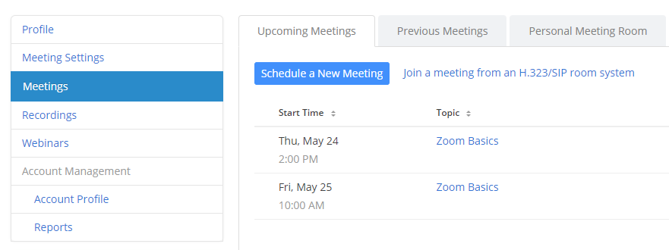
1. From the Zoom website, https://zoom.us/ log in to My Account.
2. Click Meetings on the left hand side and follow the prompts to schedule a meeting
2
3. To start an unscheduled meeting, click on Host a Meeting.

Hosting a Meeting

Once you have started a meeting, you will be prompted to download Zoom and join audio and start video. It is a good idea to Test Computer Mic & Speakers prior to starting your meeting.

Zoom Menu Bar (Host)

The Participant Experience

Joining a Meeting
Zoom Meeting PARTICIPANT
Best Practices
- Always use mute when you are not actively speaking.
- Test your audio every time you sign in.
- Sign on several minutes before a meetings begins so you can address any AV issues.
- Use the chat feature to ask questions or share URLs and files.

Want to make sure your system is compatible with Zoom? Visit https://zoom.us/test to join a test meeting.
A Zoom account is not required to join a meeting. As a participant you will most likely receive an invitation by email or calendar invite with a link or meeting ID. Zoom is available for PC, Mac, Linux and via the Web as well as mobile platforms like IOS, Android and Blackberry.

To join the meeting:
1. If you have a link, click on it directly to join the meeting. You will be prompted to download and run Zoom.
2. If you have a meeting ID you can open the Zoom application on your device or computer or visit the Zoom website, https://zoom.us/ . Click on Join Meeting and enter the meeting ID to begin.
3. Once the host has started the meeting, you will be prompted to join audio and start video. It is a good idea to Test Computer Mic & Speakers prior to starting your meeting.

Zoom Menu Bar (Participant)

Teaching with Zoom
Teaching with Zoom
Best Practices
- Practice (Teacher and Student)
- Make sure the camera is at a good angle, make eye contact w/camera
- Pay attention to your background
- Work out tech issues beforehand.
- Mute participants (encourage self-muting)
- Be creative
- Share what you learn with colleagues
Be Creative
Some features to experiment With
- Attention Tracker
- Polls
- Breakout Rooms
- Closed Captions
- Gallery View
- Whiteboard
- Annotation
Here are just a few of the ways you can use Zoom in your classroom:
- Virtual Field Trips
- Guest Lectures
- Language Practice
- Role Playing
- Study/Tutoring Sessions
- Group work
- Problem Solving
- Presentations
- Online Office Hours
- Review Websites

